Making Payments in OpenGov
If your project does not need to go through plan review this screen will appear after you have submitted your application. You may need to refresh your page, if this screen does not come up, then click on permit fee payment. 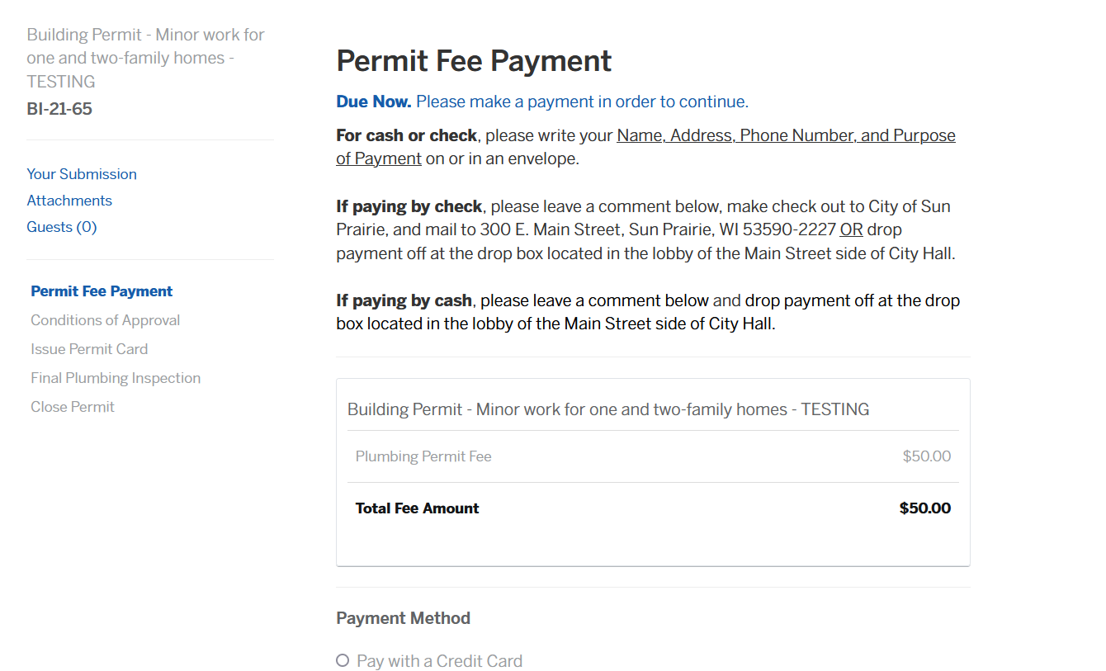If paying with card:
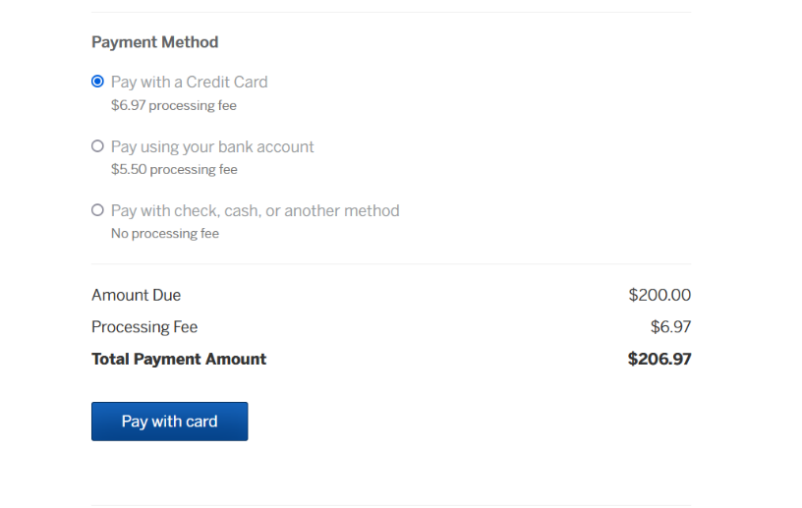

Select pay with credit card

Then select pay with card

Fill out your personal information

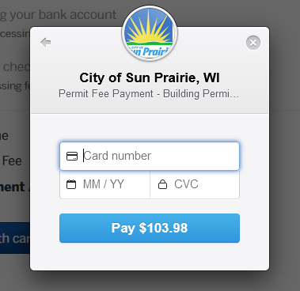
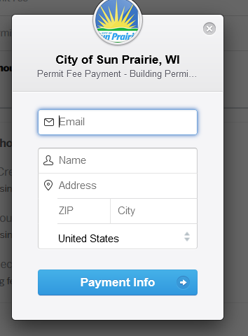
Then click payment info

Then fill in the card information and select pay

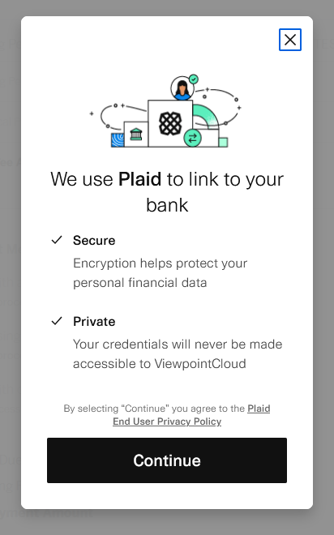
If paying with bank account: 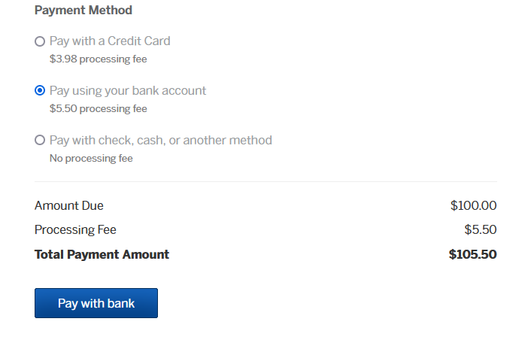
Select pay using bank account then pay with bank
Then follow the instructions through this program

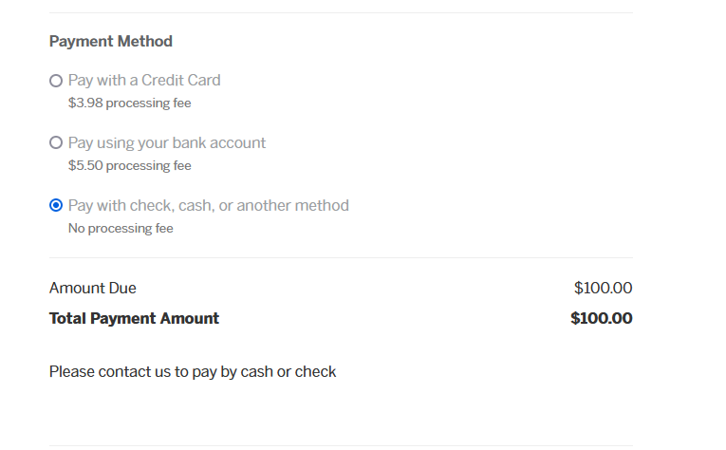
To pay by cash or check you will need to do that in person or by mail to 300 E Main St, Sun Prairie

Once you have paid for your permit, or once it has been approved, you can then print your conditions of approval and your permit card. The permit card should be visible to the road during the project. You can find both of these on the left edge of the screen
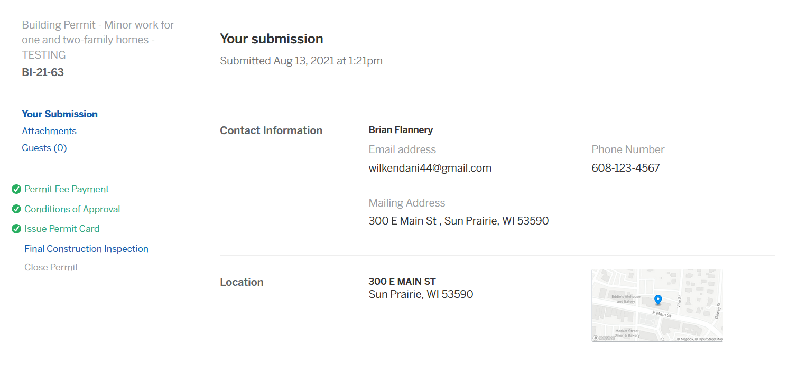

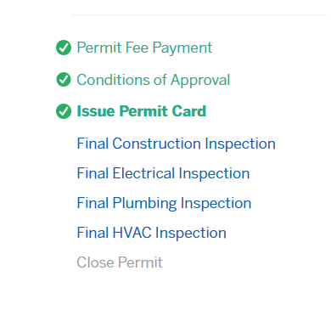

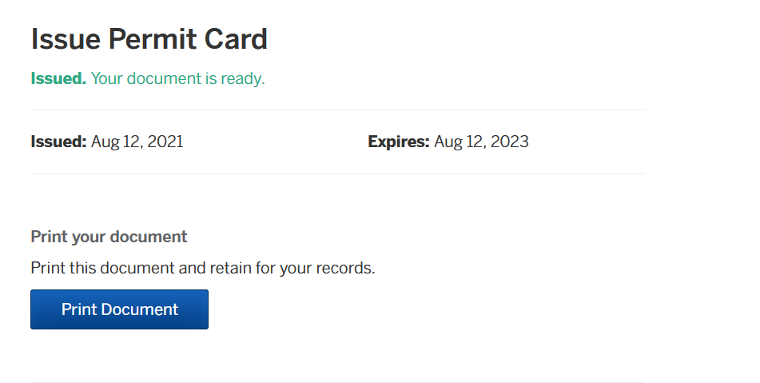
Once you’ve selected the document you want select print document
