Freestanding buildings and structures
This application should be used for freestanding buildings and structures associated with a one or two-family dwelling, such as yard sheds or detached garages, fences, swimming pools, gazebos and pergolas. If this does not describe your project, please see the following.
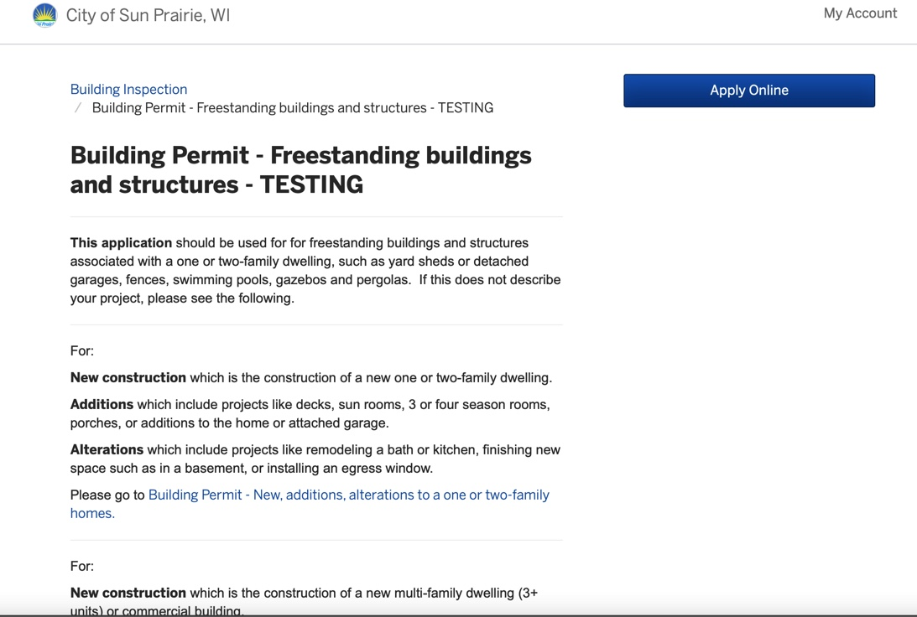

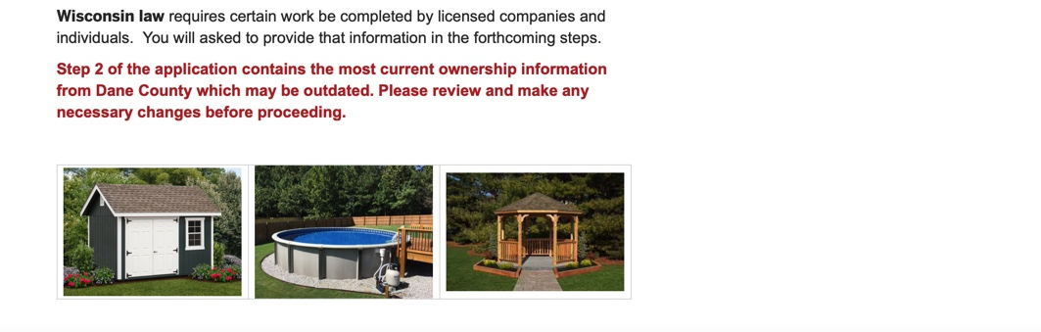
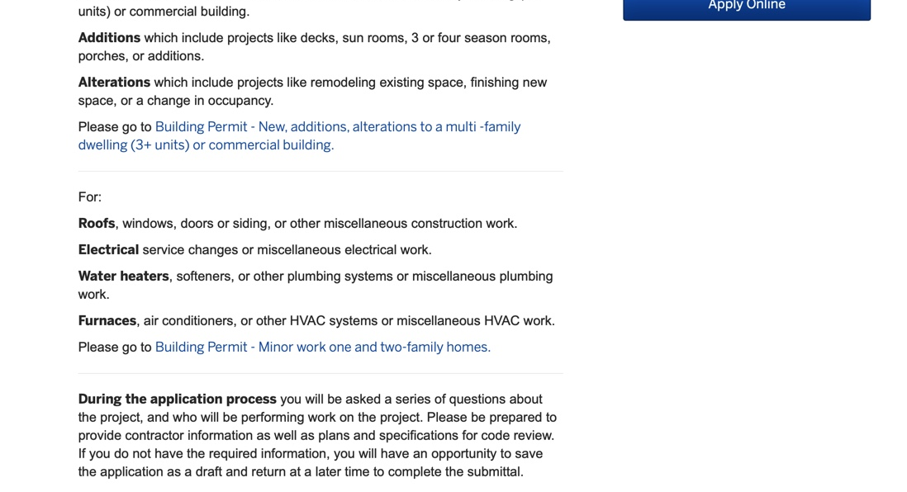
aaaaaaaaaaaaaaa

- Similar to all other applications you will fill out the step-by-step process and attach all required documents.

- You will be asked to pay the permit fee once you’ve completed your permit application. *Please contact the Building Inspection Division if you wish to pay with cash or check* (If you have any questions regarding payments, please view our “Making Payments in OpenGov” document.)



